UNIT 4 MEASUREMENT TECHNIQUES
Hot-Wire Anemometers

In constant temperature hot-wire anemometer systems, the wire resistance Rw is always kept constant and not allowed to fluctuate. The current is made to decrease or increase as soon as the hot-wire changes its resistance due to flow velocity fluctuations. The current adjustment is automatically done by employing a servo amplifier that has a feedback capacity for a frequency range from 0 to many kHz. A schematic diagram of a typical constant temperature hot-wire anemometer is shown in Figure . Basically it consists of a Wheat- stone bridge, a feedback electronic servo amplifier, a high-gain amplifier, and an R.M.S. voltmeter.
The following are the advantages of CTA.
• Because the feedback takes place almost instantaneously, keeping the wire temperature and hence its resistance at a predetermined value, no compensator is needed.
• The compensation for the thermal inertia of the filament is continuously adjusted automatically as its operating point varies. Thus, when taking a traverse of a jet, wake, or boundary layer with a CTA, there is no need for a special calibration and compensator setting for each U.
• In spite of the nonlinear calibration, it is possible in certain cases to apply an inversion formula to the output signal for reconstructing the input waveform of velocity even for large signals.
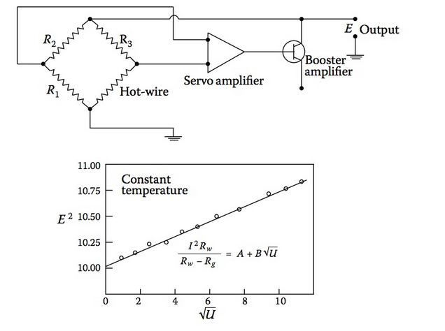
Constant Temperature Hot-Wire Anemometers
The CTA has become more popular than CCA for the following reasons.
• The CCA is calibrated at constant temperature, and then used in a pseudo-constant current mode.
• The CCA calibration has to be a static one because to obtain a constant temperature calibration, each operating point of the bridge has to be adjusted manually.
• The CTA is used in the same way as it is calibrated.
• The temperature of the wire is maintained approximately constant automatically by a feedback circuit and this makes it possible to calibrate the system dynamically.
Using modern solid-state devices, the physical size of the servo amplifiers can be made very small. However, when very high frequencies beyond 20 kHz are involved, a constant current system has to be resorted to due to limitations posed by the feedback system. Such high frequencies are involved only in supersonic flows.
In reality, the constant temperature anemometer does not hold the wire exactly at constant temperature. The wire resistance has to vary by a small amount so as to give the amplifier a feedback signal.
Relation Between Flow Velocity and Output Voltage
In a constant temperature hot-wire anemometer system, the flow velocity and the output voltage of the servo amplifier are related as follows.
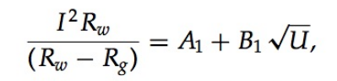
where Rw and Rg are constants. Therefore, I = E/Rw, where E is the voltage.
The above equation may be expressed as
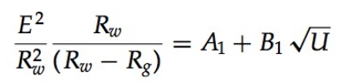
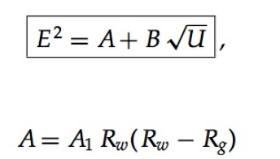

The fluctuating voltage e′ is related to the fluctuating velocity u′ in the following manner.
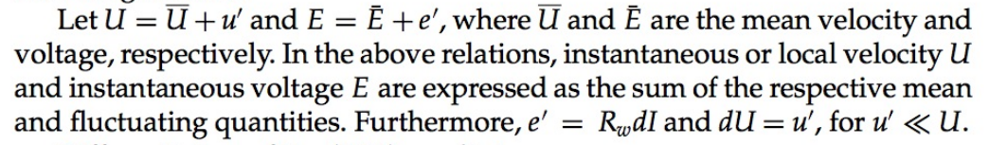
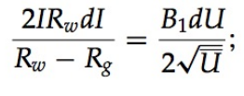
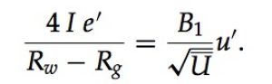

Solving for u′, and writing I as E/Rw, we get
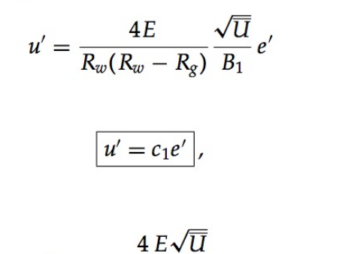
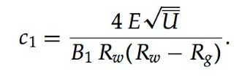
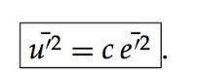
The other components of mean and fluctuational velocity components can be measured with CTA.

Hot-Wire Probes
The most important component in a hot-wire system is the hot-wire probe or hot-wire filament. The hot-wire element is usually made of platinum or tungsten wire about 1 mm long and about 5 micrometers in diameter. The wire is soldered to the tips of two needles, as shown in Figure , which forms the probe.
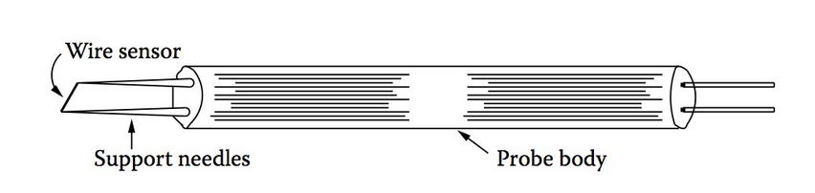

Hot-wire probe

Platinum–rhodium alloy wire is also used instead of pure platinum to give extra tensile strength to the hot-wire element. For laboratory turbulence measurements, wires with diameters in the range 4 to 8 micron and length 1 or 2 mm are used. Platinum wire can be soldered with the support needles, whereas the tungsten wire has to be welded.

The platinum wire is sold in the form of woolaston wire, which is nothing but a fine platinum wire (or platinum–rhodium alloy wire) coated with a thick film of silver. The increase in wire diameter due to the coating facilitates easier handling and soldering of the wire to the tips of the support needles. The required portion of the wire is etched with dilute nitric acid. Silver gets dissolved in nitric acid, leaving the platinum bare. Etching can be done by allowing a small jet of acid to impinge on the woolaston wire, through the tip of a burette. Etching can be hastened and made uniform by the passage of a small amount of electric current between the jet and the woolaston wire. A typical etching unit is shown in Figure .
Tungsten wire is directly welded to the probe terminals using a special welding setup. Tungsten has less resistance than platinum for wires having the same dimensions and hence its sensitivity to flow velocity is less. However, the tensile strength of tungsten is much superior compared to platinum.
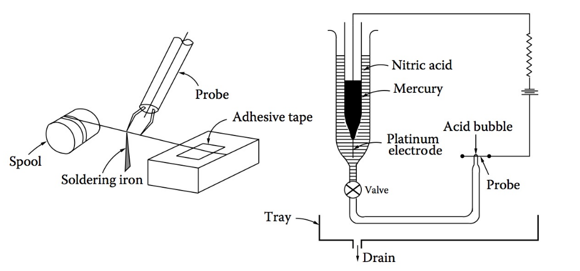

Etching unit
Limitations of Hot-Wire Anemometer
Even though the hot-wire anemometer is considered to be one of the most useful instruments for measuring turbulence, it has many limitations. Some of these limitations have become apparent in the course of our discussions in the preceding sections. These involve
• A nonlinear character of heat transfer with respect to velocity and temperature
• An onset of practical limitations due to the complex nature of the heat transfer between the wire and fluid in compressible flows
• A limitation set by the resolution power in space, that is, in the direction of the wire, due to its finite length
• A limitation set by resolution power in time, in the flow direction, due to the finite time constant of the hot-wire
Many other limitations that are both fundamental and applied in nature have been investigated by numerous researchers in this field. A fine collection of such limitations has been presented by Hinze (1987).
Although the hot-wire, as of today, cannot be treated as a completely dependable instrument, it is definitely a useful and powerful instrument be- cause it gives an estimate of some of the quantities associated with one of the complex and little-understood topics in science, namely turbulence. How- ever, we should realize at this stage that for an understanding of turbulence one has to be very very careful in using the hot-wire anemometer. In fact, we must have a fairly good command of the fundamentals of fluid dynamics before even touching the hot-wire anemometer, otherwise, whatever we do will prove to be futile both to the field as well as to ourselves.

Laser Doppler Anemometer
The novel method of measuring velocities in fluid flows using the laser Doppler technique has been the subject of rapid development in the past few decades. The usefulness and reliability of this instrument in the measure- ment of low- as well as high-speed flows have been successfully established. This technique is commonly referred to as laser Doppler anemometry or laser Doppler velocimetry. In short, it is termed as LDA or LDV in the literature. This instrument, although somewhat expensive, has many advantages over other conventional instruments such as the pitot-static probe, hot-wire anemome- ter, and so on. The specific advantages of LDA are the following.
• The measurement with LDA is absolute, linear with velocity, and requires no pre-calibration.
• It is applicable to a wide range of flow velocities, say from 10⁻⁴ m/s to 10³ m/s.
• It has negligible probe interference.
• It has high frequency response.
• It is insensitive to temperature, hence can be used in cold flows as well as in hot flows such as rocket exhaust or plasma flows.
• It has high resolution because probe volume as small as 10⁻⁶ cubic centimeter can be obtained.
• It is capable of measuring a single component of velocity as well as its temporal variations. It is possible to measure even reversals of flow direction, with an appropriate optical configuration.
LDA Principle
The principle underlying the laser Doppler anemometer is that a moving particle illuminated by a light beam scatters light at a frequency different from that of the original incident beam. This difference in frequency is known as Doppler shift, and it is proportional to the velocity of the particle. In fluid flows where the velocities are much lower than the speed of light the Doppler shift is small and orders of magnitude less than the frequency of the incident beam. The detection of it is possible only if the light source is highly stable. Laser is the ideal light source for this purpose. The word Laser stands for light amplification by stimulated emission of radiation. For instance, the Doppler shift encountered in high-speed flows is of the order of few MHz and the laser radiation for a helium–neon laser is about 5×1014 Hz. Even the highest-quality mono-chrometer using a conventional arc-lamp has a band of 108 Hz, whereas a laser has fundamental frequencies that are stable within a few hertz. The laser generally used is of the helium–neontyperadiatingat6328A ̊,with a power output between 5 to 50 milliwatts. However, for improved detector output, a high-power argon laser (1 to 5 watts) is used wherever necessary.
The Doppler shift is detected by a device called a photomultiplier which gives an electrical output whose frequency is proportional to the velocity of scattering particles. This frequency is converted into voltage using electronic devices, thus, the final voltage output is a measure of the flow velocity.
For measurement with LDA, the fluid in motion should contain scattering particles. Often artificial scattering centers are introduced into the flow to increase the intensity of the scattering. These are tiny particles with a diameter of a few microns and added in very small quantities without introducing change to the gross properties of the fluid as well as to the flow.
The size of the particles being of the order of the wavelength of light, the scattering is of the Mie type and the scattered light intensity is orders of magnitude larger than Rayleigh scattering. Different materials are used as scattering particles depending on the fluid flow to be studied. The following are the commonly used scattering substances.
• Micro polythene spheres • Diluted milk droplets • Diluted smoke particles • Aerosol
• Fine alumina powder • Water–glycerin mixture droplets
Very often naturally occurring particles in city tap water and dust in the atmosphere are sufficient to act as scattering centers.
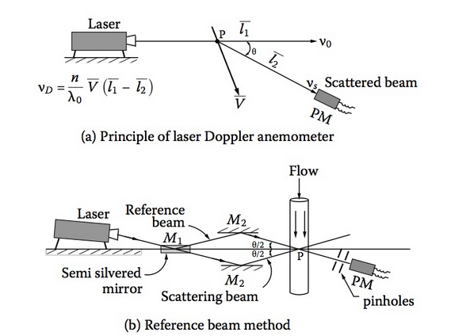
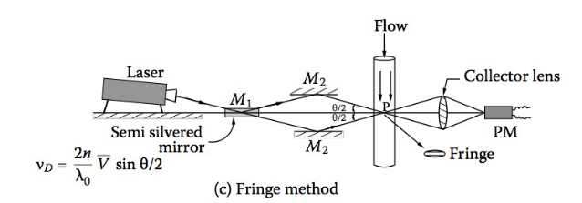

Use of Thermocouples
Thermocouples are widely used for temperature measurements in fluid streams. Thermocouples are devices that operate on the principle that a flow of current in a metal accompanies a flow of heat. This principle is popularly known as the Seebeck effect. In some metals, such as copper, platinum, iron, and chromal, the flow of current is in the direction of heat flow. In some other metals, such as constantan, alumel, and rhodium, the flow of current is in the direction opposite to that of the heat flow. These two groups are called dissimilar met- als. Thermocouples consist of two dissimilar metals joined together at two points, one point being the place where the temperature is to be measured and the other point being a place where the temperature is known, termed the reference junction.
Now, let us see the thermocouples in some detail. When two dissimilar metal wires are joined at both ends and one of the ends is heated, as shown in Figure , there is a continuous flow of current in the thermocouple circuit, in accordance with the Seebeck effect.
If this circuit is broken at the center, the net open circuit voltage, also known as Seebeck voltage becomes a function of the junction temperature and the com- position of the two metals. All dissimilar metals exhibit this effect. Some of the popular dissimilar metals are copper–constantan, iron–constantan, nickel– constantan, chromal–constantan, chromal–alumal, and platinum–rhodium. Copper–constantan is widely used in gas dynamic studies at moderate tem- peratures, because it has a temperature measuring range of −270◦C to 400◦C. For small changes in temperature the Seebeck voltage is linearly proportional to the temperature.
Measurement of Thermocouple Voltage
It is not possible to measure the Seebeck voltage directly, because we must connect a voltmeter to the thermocouple, and the leads of the voltmeter them- selves create a new thermoelectric circuit. Let us connect a voltmeter across a copper–constantan thermocouple, as shown in Figure 9.8.
We are interested in measuring only the voltage V1 due to junction J1. However, by connecting the voltmeter to measure the output of junction J1, we have two more metallic junctions: J2 and J3. But J3 is a copper-to-copper junction and therefore, it creates no thermal electromotive force (EMF) and hence V3 = 0. The junction J2 is copper-to-constantan and hence it will add an EMF (V2) in opposition to V1. The resultant voltmeter reading V will be proportional to the temperature difference between J1 and J2. This implies that, for measuring temperature at J1, the temperature of J2 must be known. One way to obtain the temperature of J2 is by physically placing the junction in an ice bath, forcing its temperature to be 0◦C and establishing J2 as the reference junction, as shown in Figure 9.9. Because both voltmeter terminal junctions are now copper–copper, they create no thermal EMF and the reading V on the voltmeter is proportional to the difference between J1 and J2.
Now, the voltmeter reading is given by
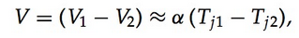
where α is a constant of proportionality called the Seebeck coefficient and Tj1 and Tj2 are the absolute temperatures. Therefore,
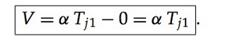

By adding the voltage of the ice point reference junction, we have now ref- erenced the reading V to 0◦C. This method is very accurate because the ice point temperature can be precisely controlled. The ice point is used by the National Bureau of Standards (NBS) as the fundamental reference point for
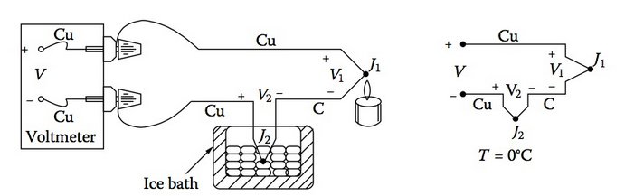
their thermocouple tables, so we can now look at the NBS tables and directly convert the measured voltage V to temperature Tj1. Even though the ice point proves to be a good reference junction, it is not a convenient one in practice, in as much as care must be taken to keep the ice in a proper enclosure and the molten water has to be removed continuously in order to keep the tem- perature of the bath at 0◦C. Therefore, in laboratories it is common practice to use baths such as oil baths kept at constant temperature as the reference junc- tion. In this case the temperature of the bath has to be added to the measured temperature to get the resultant temperature of the junction Tj1.
In the copper–constantan thermocouple, shown in Figure, the copper wire and the voltage terminal are made of the same material. But in other thermocouples such as the iron–constantan thermocouple, the iron wire in- creases the number of dissimilar metal junctions in the circuit, as illustrated in Figure 9.10, as both voltmeter terminals become Cu–Fe thermocouple junc- tions.
If the junctions J3 and J4 are not at the same temperature, there will be an error introduced in the measurement. For more precise measurement, the copper leads of the voltmeter should be extended so that the copper-to-iron junctions are made on an isothermal block, as shown in Figure
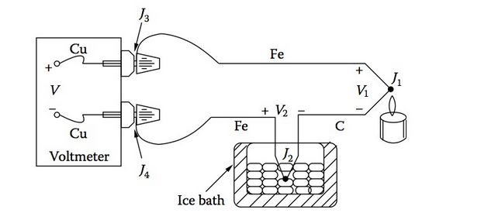
Iron–constantan thermocouple.

Temperature Measurement with Pyrometers
Optical Pyrometer
Some solids, such as metals, when hot begin to emit light with a very dull red color and as the temperature increases the color becomes a brighter red, orange, yellow, and so on. The particular color emission occurs at a particular temperature and hence can be used as a means of measuring the temperature if suitable calibration is adopted. It is this principle that is used in the optical pyrometer.
The optical pyrometer has some form of a telescope through which the high temperature object is observed. Usually the telescope will have a light filter installed in order to cut down the light intensity at the higher tempera- ture so as not to damage the eye. The telescope is focused on the object whose temperature is required, such as a furnace, reentry object, and so on. Color filters can be introduced by the side of the image of the object and the color of the filter is matched with the color of the object. There is a calibrated scale on the side of the instrument that records the temperature.
The most common optical pyrometer, however, is the disappearing fil- ament pyrometer. If the filament of a lamp has an electric current passed through it, the filament will glow. The color of the filament will depend upon the current passing though it. In the disappearing filament pyrometer a small lamp is inserted in the field of vision of the telescope. After focusing the telescope on the object, the current through the filament is adjusted such that the color of the filament merges with the color of the object and hence the fila- ment optically disappears. A meter in the filament electric circuit is calibrated to read temperature, and hence the temperature of the object is determined.
From the above discussions it is seen that the optical pyrometer is used for high-temperature measurements. Any light-absorbing gases between the pyrometer and the object or any other cause that restricts the entry of light into the pyrometer will introduce significant errors in the measurements with a pyrometer. Also, in a pyrometer using color comparison, error may occur due to color interpretation.

Radiation Pyrometer

In this type of pyrometer, arrangement is made to focus the radiant energy onto the hot junction of a thermocouple. The cold junctions of the thermo- couple are shielded from the radiation and are coupled externally to a galvanometer, as shown in Figure
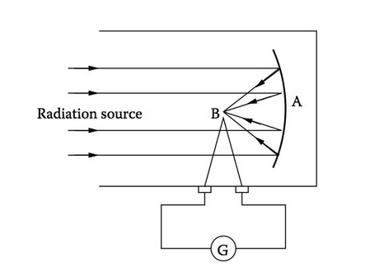

A radiation pyrometer.
As seen in the figure, the radiant energy from the radiation source is received by a concave mirror A in the apparatus. By means of a focusing adjustment the radiant energy is focused directly onto the hot junction of a thermocouple B, after reflection from the mirror surface. The galvanometer G, connected to the thermocouple, is calibrated directly to read temperature. While using, care must be taken to ensure that the reflecting power of the mirror is not impaired and hence it must be kept clean. Also, no high-energy absorbing media may come between the radiation source and the pyrometer.
Infrared Thermography
It is a technique, based on radiation, to assess energy losses by radiation. An important energy radiation level is that of the infrared waveband. This occurs at wavelengths between the appropriate limits of 10−3 to 10−6 meters. This is below the visual limit of the red color. Because it is not visible in the normal sense by eye detection, special detectors are required to record its presence. This has led to the development of infrared thermography.
In infrared thermography a detector is aimed at a surface. The infrared radiant energy is received and through subsequent apparatus, it is translated into a visual screening (bright for high temperature through to dark for low temperature), and thus energy loss by radiation can be assessed and cali- brated.
In the case of photography, infrared energy received from an object can be translated into a photographic image and, thus, such cameras can be used at night because no direct visual wavelengths are required from the energy transmitting object.
Fusion Pyrometers
The variation of melting points of certain chemical substances is utilized for temperature measurements in fusion pyrometers. Combining certain clays, metals, and salts, it is possible to obtain mixtures of these substances that soften and melt at definite temperatures. These mixtures are made generally in the form of slender cones and pyramids, as shown in Figure
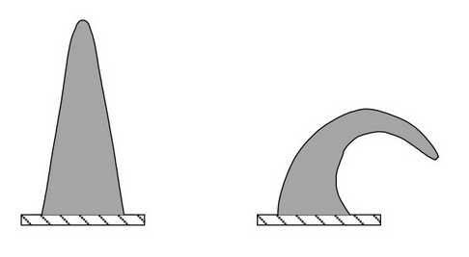

They are used for measuring the temperature of furnaces, kilns, and the like. When the required temperature is reached the cone signifies this fact by beginning to become soft and curling over, as shown in Figure. The disadvantage of this technique is that these cones can be used only once.

Pressure Transducers
Pressure transducers can be designed and built for almost any pressure gener- ally encountered in fluid flow measurements and they can also be used for remote indication. Pressure transducers are electromechanical devices that con- vert pressure to an electrical signal that can be recorded with a data acquisition system such as that used for recording strain-gauge signals. These transducers are generally classified as mechanical, electrical, and optical-type. Commonly used transducers employ an elastic diaphragm (of various shapes) which is subjected to a displacement whenever pressure is applied. This movement is generally small and kept within the linear range, and amplified using a mechanical, electrical, electronic, or optical system. A schematic diagram of a typical diaphragm pressure capsule, with strain gauges mounted on the diaphragm, is shown in Figure
The total strain produced on the diaphragm is proportional to the pressure applied. For a circular diaphragm, the deflection δ at the center is given by
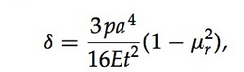
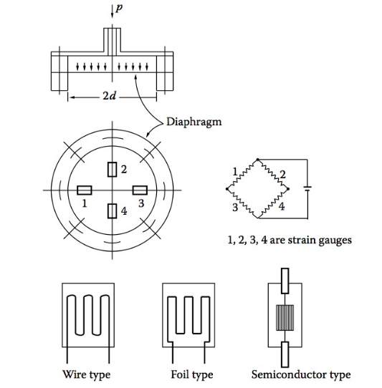

where a and t are the radius and thickness of the diaphragm, respectively; μr is Poisson’s ratio; E is Young’s modulus; and p is the pressure applied.
It should be noted that the above relation holds good for small deflections only. For large deflections, corrugated diaphragms have to be used. Usually the diaphragms are made of beryllium, copper, or phosphor bronze sheets. Heat-treated stainless steel diaphragms are also employed for pressure mea- surements. A photographic view of some strain-gauge transducers is shown in Figure.
The following are the advantages of pressure transducers over manome- ters and other pressure gauges.

• They provide a signal proportional to the applied pressure which can be automatically recorded by any data acquisition system.
• They are relatively low volume devices and consequently respond more rapidly to pressure changes.
• They are small enough to be mounted inside wind tunnel models.
Their major disadvantage relative to a good manometer is that they must be calibrated, whereas a manometer with a known fluid can be considered as a pressure standard.
Because of the relatively high cost of pressure transducers in quantity, a scheme has been devised for using one transducer to measure a number of pressures up to 48. This scheme of pressure communication uses a device known as a pressure scanni valve. In using the scanni valve, pressures from different pressure taps on a model are allowed to stabilize in the pressure tube lines leading from the model through the stator of the scanni valve. The rotor of the scanni valve is then turned through one revolution, communicating the pressures trapped in the connecting tubes in turn to the transducer through a communication slot. Likewise, all the tubes holding the trapped pressure are connected to the transducer and the respective pressures are read. Even though it is expensive, the scanni valve has a specific advantage because of the use of only one transducer for measuring a number of pressure readings. Thus, correction of measured data for any error introduced by the transducer is simple, because all the data will have the same error (if any).
Linear Variable Differential Transformer LVDT
A linear differential transformer works on the induction principle, like any other transformer, but with a movable core fixed to the diaphragm, as shown in Figure.
As seen in Figure, the LVDT consists of a primary coil, two secondary coils, and a movable iron core. The secondary coils are connected in opposi-tion. When the core is in null position between the two secondary coils the voltage induced is canceled. Any movement of the core on either side gives an output proportional to the displacement from the null point. This instrument is capable of detecting displacements of the order of a few microns. Applying known pressures, the associated displacements of the core and the corresponding outputs of the LVDT can be noted to make the calibration chart, as shown in the figure.
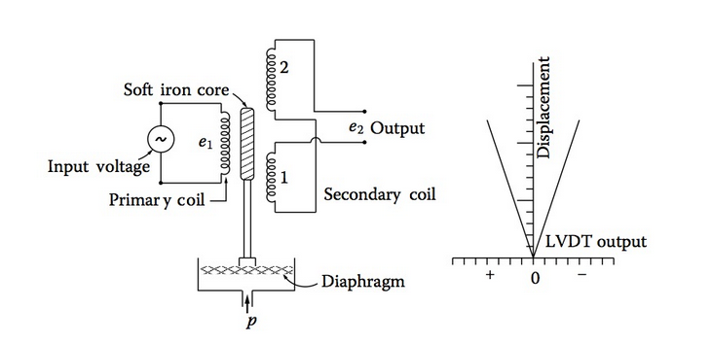

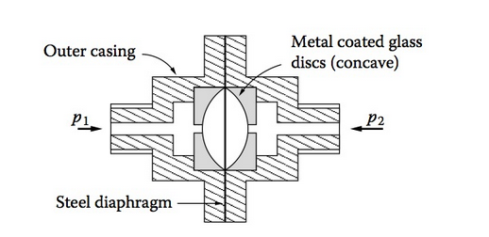

Capacitance pressure transducer
Optical-Type Pressure Transducer
A schematic sketch of an optical-type pressure transducer is shown in Figure. The pressure-sensing element is a thin diaphragm that is highly polished on both sides. When the pressures p1 and p2 are equal the diaphragm remains flat and the width of the reflected light beams a and b are the same. Under this condition the differential output from the photocells is zero. But when the diaphragm is deflected due to pressure difference, the width of the reflected beams is different. The amount of light falling on the photocells through the slits is different. This causes a differential output proportional to the difference between the pressures p1 and p2.
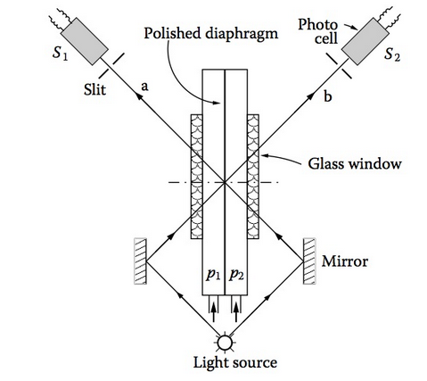
Rotameters
A rotameter is a direct-reading meter, usually employed for flow rate measure- ments in passages with small diameters. Basically it is a constant-pressure- drop, variable-area meter. It consists of a tube with tapered bore in which a float takes a vertical position corresponding to each flow rate through the tube, as shown in Figure
For a given flow rate, the float remains stationary and the vertical compo- nents of the forces of differential pressure, viscosity, buoyancy, and gravity are balanced. This force balance is self-maintaining because the flow area of the rotameter, which is the annular area between the float and the tube, varies continuously with the vertical displacement of the float, thus the device may be thought of as an orifice of adjustable area. The downward force, which is the gravity minus the buoyancy, is constant, therefore, the upward force, which is due to pressure drop, must also be constant. Because the flat area is constant, the pressure drop should be constant. For a fixed flow area, the pressure drop 􏰃p varies with the square of the flow rate, and so to keep the 􏰃p constant for different flow rates, the area must vary. The tapered tube of the rotameter provides this variable area. The position of the float is a measure of volume flow rate, and the position of the float can be made linear with the flow rate by making the tube area vary linearly with the vertical distance.
Assuming incompressible flow, the volume flow rate Q ̇ can be expressed as
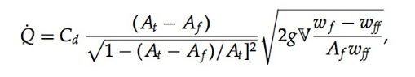
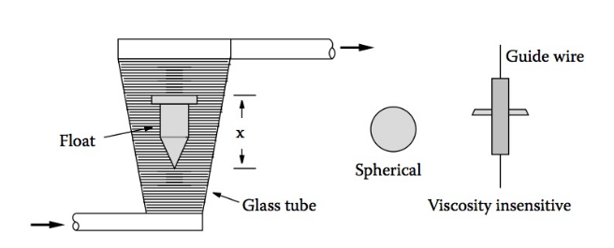

where C_{d} is the discharge coefficient, At is the area of the tube, A_{f} is the area of the float, g is the gravitational acceleration, V is the volume of the float, w_{f} is the specific weight of the float, and w_{f} is the specific weight of the flowing fluid.
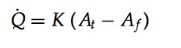
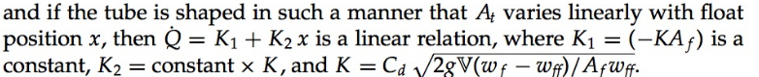
The rotameter floats may be made of various materials to obtain the de-sired density differencew _{f}− w_{ff} for metering a particular fluid. Some float shapes, such as spheres, require no guiding in the tube; others are kept central by guidelines or by internal ribs in the tube. Floats shaped to induce turbulence can give viscosity insensitivity over a 100:1 range.
The tube is usually made of high-strength glass to allow direct observation of the float position. For higher strength, metal tubes can be used and the float position detected magnetically through the metal wall. When an electrical or pneumatic signal related to the flow state is wanted, the float motion can be measured with a suitable displacement transducer. Accuracy of the rotameter is typically ±2 percent full scale and repeatability is about 0.25 percent of the reading.

Ultrasonic Flow Meters
The fact that small-magnitude pressure disturbances travel through a fluid medium at a definite velocity, the speed of sound, relative to the fluid is made use of in ultrasonic flow meters. The word ultrasonic refers to the fact that in reality the pressure disturbances generally are short bursts of sine waves whose frequency is above the range audible to human hearing (about 20 kHz). A typical frequency may be about 10 MHz.
Ultrasonic flow meters make use of transmitters and receivers of acoustic energy in their measurements. A common approach is to utilize piezoelec- tric crystal transducers for both functions. Electrical energy in the form of a short burst of high-frequency voltage is applied to a crystal in a transmitter, causing it to vibrate. If the crystal is in contact with a fluid, the vibration will be transmitted to the fluid and propagated through it. The receiver crystal when exposed to these pressure fluctuations responds to this vibration. The vibrating motion of the crystal produces an electrical signal proportional to the vibrational excitation, in accordance with the usual action of piezoelectric displacement transducers.
Application of these principles is illustrated in Figure
